Glenn Hills Middle School

LIBRARY MEDIA CENTER HANDBOOK

Seminole Pride



**“Reaching for the Top of the Hill!”**

Elicia Rice

Media Specialist



Table of Contents

Mission and Goals ...........................................................................................................3

Points of Interest ………………………………………………………………………...4

Media Center Policies & Procedures …………………………………………………....5

Student Visits ………………………………………………………………………........6

Class Visits ………………………………………………………………………........... 6

Accessibility ………………………………………………………………………......... 6

Circulation Policy ……………………………………………………………………… 7

Damaged and Lost Material……………………………………………………….......... 7

Internet Use ……………………………………………………………………….......... 8

BYOT ………………………………………………………………………....................8

Building Media and Technology Committee ...................................................................8

Selection of Materials for the Media Center ....................................................................10

Gifts ……………………………………………………………………………………..11

Reconsideration of Material …………………………………………………………….12

Printers ………………………………………………………………………………….13

Poster Making &Laminating ………………………………………………………….. 14

Technology Resources …………………………………………………………………15

Online Public Access Catalog (OPAC) ………………………………………………..15

Copyright Policies, Procedures, and Guidelines ……………………………………….16

APPENDIXES

Video Forms ………………………………………………………………………………18

Reconsideration Form …………………………………………………………………….19

Continuation of Reconsideration Form ……………………………………………………20

Stolen or Missing Equipment Form …..…………………………………………………...22

Loan of Equipment Form ………………………………………………………………… 23

Glenn Hills Middle School Media Center’s mission is to provide a welcoming learning environment that supports the mission and instructional program of the school creating lifelong learners and productive citizens. We support creative thinking, development of good research skills, and engaging collaborative learning opportunities. The Glenn Hills Media Center also encourages the use of information and technology ethically and effectively and support community involvement in an effort to help students grow intellectually.



* Equitable access to up to date resources to every student
* Instructional materials that will stimulate intellectual growth
* Information that will enable students to make intelligent, informed decisions in their daily lives
* Technology options for all students, as well as print and non-print materials, in their quest for knowledge
* A culture that nurtures reading and learning
* A clean, organized, and safe environment
* Collaborative culture that emphasizes joint determination by Media Specialists and Teachers to ensure the use of Media Center resources and services that support classroom instruction.



POINTS OF INTEREST

The media center is an intricate part of the education process in the Richmond County School System. The media center plays it role in the process by promoting reading, proper use of technology, and using the media center to various avenues of learning.

We promote information literacy and reading for please. The media center provides a safe and clean environment for the use of technology and research. Students, faculty and staff, as well as parents are encouraged to use the media center for their personal and professional needs.

As a forerunner for the future of our child the media center provides up-to-date resources in textbook form and access to modern technology. The teachers and the media specialist collaborate in a team effort to enhance students academically.

Team work makes the Dream work and the media specialist is a part of the educational team at Glenn Hills Middle School and in the Richmond County School System.

**SCHOOL LIBRARY MEDIA CENTER**

Library Media Contact: Mrs. Rice

706-796-7405 ext. 111

Operating Hours

Monday - Friday

Students 8:30 a.m.-4:00 p.m.

Faculty and Staff 8:15 a.m.-4:45p.m.

**Policies and Procedures**

**A. Class Visits -** Media center use and research are encouraged and should be scheduled in advance so that adequate work space and materials can be made available. Teachers should remain with their classes and are responsible for the discipline of their students. Because of obvious reasons, media center use should not be part of substitutes' plans unless arranged in advance with the media specialist.

**B. Student Visits-** Teachers may send small groups of no more than five students throughout the day. Students must sign in upon entering the media center. Students must have a pass to enter the media center. The pass must include the student’s name, the teacher’s name, the time the student left the classroom, and the student’s assignment. Students who are sent to the media center and who fail to follow media center behavior procedures will be disciplined appropriately.

**C. Accessibility**

State law requires school media centers to operate on a flexible schedule. The flexible concept includes:

* It is Richmond County policy that the teacher remains with his/her class
* The media center should be available for students and teacher to use according to instructional need rather than a predetermined schedule
* The media center is open to individual students, small groups of students, and faculty at all times
* Cooperative planning between the media specialist and teachers shall help optimize utilization of the available resources

The media specialist is available to collaborate with teachers on the integration of technology and/or library media skills into the curriculum. Teachers must complete a Collaboration Form and plan the lesson with the media specialist at least one week in advance.

A sign-up sheet is located on the bookcase next to the circulation desk in the media center. Teachers may sign up for classroom use of the media center in the form of whole class checkout, research, information literacy lessons, collaborative lessons, or for special speakers. Teachers must sign up for classroom use of the media center at least one day in advance.

**D. Audio-Videotape/DVD Policy Materials/Equipment –** Items such as video recordings and equipment, are available to enhance instruction. Materials can be found on GHMS’s OPAC, Destiny. All videos or movies contained in the Media Center’s collection should be directly related to the curriculum. The movie rating must be appropriate to the grade level where 10 the movie is being shown. For any movie with a PG-13 or R rating, a parental permission note must be sent home. Students must not be penalized for not being able to watch a movie in which they did not receive parental permission to watch.

**E. Technology Based Resources -** Technology which includes educational and productivity software, online resources, as well as an on-line library catalog and circulation system, is available for both student and teacher use. Media specialists are available to assist in the use of these technologies. Teachers and students can check with the media staff to find out their login information.

Software is different from other purchases, because it requires licensing and support. Often, it is intangible and web-based. It is extremely important that all software purchases be approved by the Richmond County School System for:

1. Alignment with the Georgia Performance Standards (Instructional Software)

2. The learning styles of students (Instructional Software)

3. Evidence of effectiveness

4. Total cost of ownership

5. Manufacturer support

6. Compatibility with the RCSS network (including bandwidth and hardware requirements) Instructional Software Guidelines Individual schools or teachers should not use software unless it has met approval. Schools, Departments or employees requesting specific software must submit a Software Evaluation Form. This form will be reviewed by the appropriate subject area Coordinator or Director. After the Director or Coordinator approves the form, it will be submitted to the Technology Department to determine network compatibility. After receiving approval from both Curriculum and Technology, the school, department or employee can proceed with ordering.

A file of all computer information including serial numbers is housed in the media center. It is the responsibility of each classroom teacher to protect their passwords and to keep their equipment clean and operational. **The media specialist is not a technician, but can troubleshoot minor problems when the need arises.** If the repair needs the attention of a technician, the classroom teacher is required to submit a [Tech Request](https://www.rcboe.org/Page/36429) via the SchoolDude Link . The technician will receive the request service your technology. Please be sure that all required fields are complete before submitted the ticket so that there will not be any delays in getting your equipment repaired. Do not move any equipment from your classroom for any reason. This will be done by the technician.

**F. Internet Use -** Teachers and the library media staff will monitor student access to the Internet. Use of the Internet by students should only be for school-related purposes.

**G. BYOT** – GHMS allows students to Bring their Own Technology. Students should follow the same Internet AUP as with any school technology. Students are responsible for their own technology in the media center. Media staff is not permitted to repair student technology. **Cell phones are not allowed to be used in the media center** unless they are with their class and their teacher approves. The media center allows students to charge their technology as needed **(not cell phones)**.

[**Click here**](http://www.rcboe.org/cms/lib010/GA01903614/Centricity/Domain/83/BYOTPacket_rev8.2015.pdf) **or visit the RCBOE website for full details on the BYOT policy and procedures.**

**Circulation Policy:**

**Students**: Students are allowed to check out as many books as they will honestly read in a two week period. If an additional material is needed for the specific completion of school assigned work, the media staff, at their discretion, may allow additional checkout(s). Students are asked to be considerate of the needs of everyone utilizing the Media Center, and return materials as soon as they are finished with them. Access to all materials within the fiction and non-fiction areas of the Media Center is allowed. Reference materials and magazines do not circulate, but are for use within the Media Center only.

**Faculty & Staff:** Access to all Media Center materials / areas is allowed. Limited reference material may be checked out for a single day, for use within the classroom (i.e.: an almanac or atlas may be taken for classroom use, provided it is returned at the end of the day.) Faculty and staff are asked to be considerate of the needs and wishes of everyone utilizing the Media Center, and return borrowed materials as soon as they are finished with them.

**Sensitive Materials:** Materials which are considered to be of a sensitive nature: for example, materials with more mature content, which may be related to health or political issues, may require a parental permission form for check-out. Such materials will be given a sensitive designation after review by the building level Media & Technology Committee.

**Damaged and Lost Materials:**

**Charges**: Students and faculty, who damage or lose Media Center materials, are required to pay for the repair or replacement cost of the materials. Materials includes print, video, software and audio items, as well as equipment such as computers, printers, monitors, cameras, and video-cameras. The cost of lost items will be assessed at the actual cost of the lost materials; damages will be assessed at the cost of making repairs. No less than $5.00 will be assessed for the loss of any older book, with a record that pre-dates the addition of a material cost notation. This is in accordance with district policy. Labels (barcode, Accelerated Reader, spine and other labels) removed from a book will be charged at the cost of $2.00 per label for replacement.

**Accountability for Lost and Damaged Items**: Students and teachers are held accountable for all items checked out in their name. Responsibility is not mitigated even if library materials are entrusted to a friend , sibling or another teacher. If a material is lost or damaged by another person while checked out under a student‘s or teacher’s name – the person who checked the material out is still responsible for making restitution for the material.

**Payment for Damages or Losses**: Please contact the Media Specialist about any concerns there may be over accountability or payment. Our primary interest is to maintain the access students and faculty have to the Media Center, and we‘re happy to work with you on any concerns.

**Overdue Books**: At this time, GHMS does not assess fines for moderately (a week or two) overdue books. Books that are severely overdue (a month or more) may be considered to be lost, and the student charged accordingly unless s/he produces the missing material, in good repair. Students with severely overdue books need to be aware that they are curtailing their ability to fully utilize the Media Center. Additional books may not be checked out until the matter of an overdue book is settled satisfactorily.

The Building Media and Technology Committee

The committee will meet as often as needed or as required to meet the school’s needs. The committee is charged with making recommendations for the media program in the school concerning:

1. Long- range program goals for all types of media used by the instructional program

2. Budget priorities

3. Reconsideration of materials

4. Operational procedures

5. Copyright adherence policies, including appointing an individual responsible for providing copyright information and obtaining copyright clearance where necessary

6. Program evaluation, including expansion and deletion of services

7. Policies for disposition of gifts

8. Policies for the use of non-school owned materials in the classroom

9. Mechanism for the use of information sources outside the school

10. Assist the media specialist in evaluating and prioritizing requests from the faculty and students for additions to materials in the media collection.

The Media Specialist shall be responsible for organizing and working with the Building Media Committee. The Media Specialist shall be guided by, but not limited to, the suggestions of the Building Media Committee. It is, and shall remain, the Media Specialist’s responsibility to order all print, non-print and audio-visual materials and equipment to ensure a balanced collection is available for instructional use in the media center



Selection of Materials for the Media Center

Selection policies shall include:

1. Providing materials that enrich and support the curriculum, taking into consideration the varied interests, abilities and maturity levels of the students.

2. Providing materials that will stimulate growth in factual knowledge, literary appreciation, aesthetic values and ethical standards.

3. Providing material, which will enable students to make intelligent judgments in their daily lives.

4. Providing materials on opposing sides of controversial issues so students may develop, under guidance, the practice of critical reading and thinking.

5. Providing materials on many religious, ethnic and cultural groups and their contribution to our heritage.



Gifts

While gifts are generous, they must be judged in light of their benefit to the school’s instructional program. Gifts should be accepted only if they add to the strength of the media center’s collection.



Reconsideration of Materials

In a democracy, opinions differ, and occasionally there may be criticism of the most carefully selected materials. In the case of a complaint, the following procedures shall be followed:

* The complainant will file the complaint, in writing and on the approved form, with the school administrator. (See Appendix B)
* The school administrator will refer the complaint to the Building Media Committee to consider the validity of the complaint. After reviewing the complaint, the committee will read, watch or listen to the material in question and write an answer to the complaint, detailing their opinion of the item in question in a timely manner.
* The Building Media Committee will meet with the complainant to discuss the item and try to reach an amicable and acceptable decision of the issue.
* A written report of all actions taken by the Committee will be sent to the school’s Principal.
* If the complainant does not accept the decision of the Committee at the local school level, the complaint shall be referred to the County Committee. The County Committee shall follow the same procedure and make recommendations.
* If the complainant does not accept the decision of the Richmond County Media Committee, the ultimate decision will be the responsibility of the Board of Education.
* The appropriate form shall be the Form for Reconsideration of Materials found in the Appendix. Copies of this form should be kept on hand to give to anyone approaching the principal, teacher or media specialist with a complaint.

Printers

Glenn Hills Middle School Media Center has one printer on which students are allowed to use for printing. All desktop computers (in the Media Center) are wirelessly connected to the printer. Therefore, students, teachers, and others may use any computer to print. There is a Print Fee of $.15/page in black and white, and $.25/page in color.

Each teacher may also connect to printers located on each hall’s workroom, in the collaborative planning room and/or their personal printers in their rooms for their instructional needs.



Poster Making & Laminating

Staff members are asked to complete the request form and attach to documents to be made into Posters &/or laminated. Please do this by 4 p.m. on Tuesdays and pick up after 12 noon Wednesdays. The machines are turned off until needed in an effort to reduce fire hazards and the waste of energy.

Should anyone use the CoLam located in the computer work room please notify the media specialist of jams/damages to the machine or as to when the machine needs to have its paper replaced.

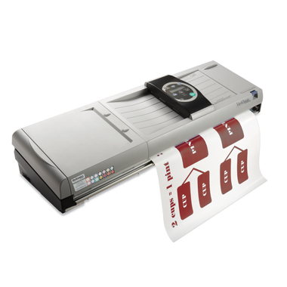

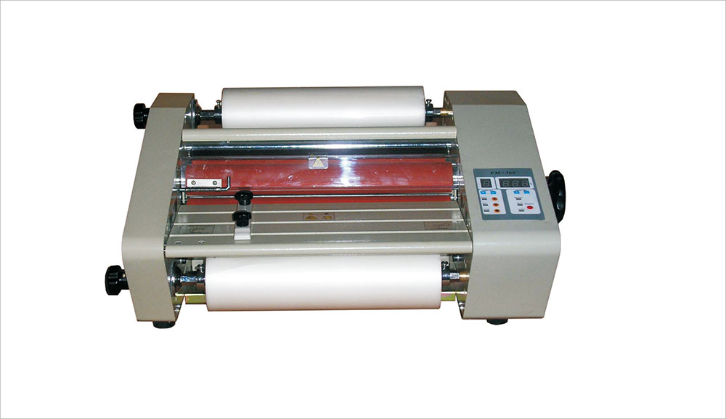

Technology Resources

* [Destiny](https://rcboe.follettdestiny.com/common/welcome.jsp?context=saas60_1014545)
* [Galileo](https://www.galileo.usg.edu/teen/rcboe/search/)
* [I-Ready](http://www.I-ready.com)
* MyOn
* [Scholastic Magazine](https://digital.scholastic.com/#/signin/staff?app=scope&state=%2F&role=staff)
* [Edmodo](http://www.edmodo.com)
* [NewsELA](https://newsela.com/)
* [Georgia Public Broadcasting/United Streaming](https://app.discoveryeducation.com/public:session/login)
* [USA TestPrep](https://www.usatestprep.com/member-login)
* [Achieve3000](https://login.achieve3000.com/index)

Online Public Access Catalog (OPAC)

OPAC is an online bibliography of a library collection that is available to the public. It is an online cataloging system of materials listed in a library.

An OPAC (Online Public Access Catalog) <https://rcboe.follettdestiny.com> is an online bibliography of a library collection that is available to the public.



Copyright Policies, Procedures, and Guidelines

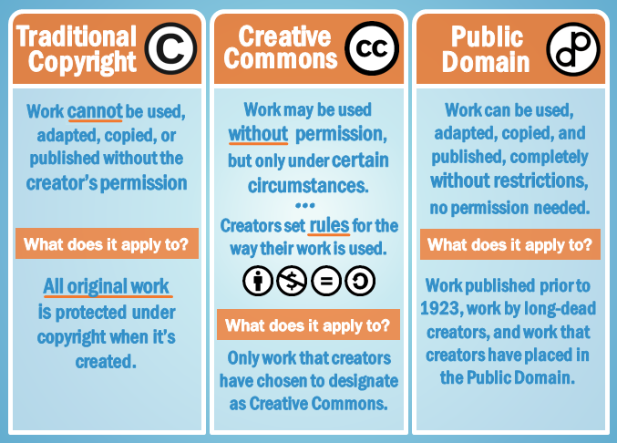

**APPENDIXES**

**REQUEST TO SHOW SCHOOL VIDEOS**

Request to Show School Videos Must be submitted one week (1) prior to date of use to allow for scheduling

TITLE OF VIDEO ____________________________________________________________

LENGTH OF VIDEO ______________________ (HRS &/OR MINS)

SOURCE OF VIDEO ___________________________________________________________

RELATIONSHIP TO CURRICULUM _____________________________________________

______________________________________________________________________________

DATE I WISH TO SHOW THE VIDEO____________________________________________

I request the above listed video for use in my classroom for the above stated educational reason.

TEACHER ________________________________ DATE______________________________

*************************************************************************************

**REQUEST TO SHOW NON-SCHOOL VIDEOS**

Request to Show Non-school Videos Must be submitted two weeks (2) prior to date of use to allow for previewing.

TITLE OF VIDEO ______________________________________________________________

SOURCE OF VIDEO____________________________________________________________

RELATIONSHIP TO CURRICULUM ______________________________________________

______________________________________________________________________________

DATE I WISH TO SHOW THE VIDEO ____________________________________________

I request the Building Media Committee preview the above listed video with the intent that it be used in my classroom for the above stated educational reason.

***********************************************************************

_______Approved

_______Disapproved

DATE ____________________Media Specialist______________________________________

PRINCIPAL___________________________________________________________________

**FORM FOR RECONSIDERATION OF MEDIA**

Media consists of all types of print and non-print materials.

Type of media _________________________________________________________________

Name of item___________________________________________________________________

Publisher and/or Author__________________________________________________________

Complainant’s Name ____________________________________________________________

Address Street City State Zip ______________________________________________________

Telephone (Home)__________________________ (Work) _____________________________

**Complainant Represents**

_______Him/herself

_______Organization (Name)

_______Other Group (Identify)

1. Did you read, view or listen to the complete item: Yes_____________ No____________
2. How was the item acquired (Assignment, free selection, from a friend, etc.)
3. Is the item part of a series? Yes ____ No _____ If yes, did you read, view or listen to the set or series? Yes___________ No__________

4. What is objectionable regarding the item and why? (Be specific)

5. Were there good sections included in the item? Yes______________ No_____________

If yes, please list them:__________________________________________________

______________________________________________________________________________

____________________________________________________________________________________

_____________________________________________________________________________________

_____________________________________________________________________________________

**FORM FOR RECONSIDERATION OF MEDIA-Page 2**

6. What do you feel might be the result of using this material? ___________________________

_____________________________________________________________________________

_____________________________________________________________________________

7. What do you believe is the theme of the material? ___________________________________

_____________________________________________________________________________

8. Did you locate reviews of this item Yes _____ No ____

If yes, please cite them: ___________________________________________________

If no, why not? __________________________________________________________

9. Did the review(s) substantiate your feelings? Yes __________ No __________

10. Is there any educational merit to the item? Yes ___________ No __________

If yes, what do you feel would be the approximate grade level(s) _______

11. How do you see the item being utilized in an educational program?

______________________________________________________________________________

12. List the person(s) with whom you have discussed this item.

Name ______________________________Title/Occupation_____________________________

Address ______________________________________________________________________

13. What were their reactions and/or opinions? ________________________________________

______________________________________________________________________________

14. What do you suggest be done with the item in question? _____________________________

______________________________________________________________________________

15. What do you suggest be provided to replace the item in question? ______________________

______________________________________________________________________________

Signature of Complainant: _______________________________________ Date: ___________

**RICHMOND COUNTY BOARD OF EDUCATION**

**MEMORANDUM**

**STOLEN OR MISSING EQUIPMENT**

TO: ALL MEDIA SPECIALISTS

FROM: TRACIE LIVINGSTON

**STOLEN OR MISSING EQUIPMENT**

Please fill out the information below any time there is equipment missing or stolen from your media center.

School ______________________________________________________ Date ____________

Item _________________________________________________________________________

Grant Funded? Yes or No (Circle one) Year ___________ Purchased Price _________________

Purchase Order No._____________________ Brand Name of Equipment __________________

Model Number ___________________________Serial Number __________________________

Location of equipment when stolen _________________________________________________

Additional Information __________________________________________________________

______________________________________________________________________________

______________________________________________________________________________

______________________________________________________________________________

______________________________________________________________________________

______________________________________________________________________________

______________________________________________________________________________

Media Specialist Signature________________________________________________________

**Richmond County Board of Education**

**Loan of Equipment**

Date ______________________________________Return Date__________________________

It is the borrower’s responsibility to:

• Make sure the equipment is in working order when it is checked out.

• Return the material by the due date.

• Return the material in the same condition in which it was received.

• Provide Police Report should the equipment be stolen or destroyed by fire.

Please include current replacement cost (CRC) and list each piece of equipment separately.

Model Make Serial # Current

Replacement

Cost

Computer _________________________________________________ $_____________

Monitor ___________________________________________________ $ ____________

Other equipment ____________________________________________ $_____________

** Deep Freeze should be installed on all instructional computers. Deep Freeze is set up to go into a maintenance mode from 11:00 pm to 5:00 am. Please understand that you will not be able to use your computer during this time.

Name and signature of Borrower

________________________ _________________________

(print) (signature)

School authorized signature ______________________________________________________

(Principal/Assistant Principal or Media Specialist)